15750 – 15766 NEW BUGGY TYPE PACKAGING REQUIREMENTS

(Seaway Buggy Only)STOCK CODE: 15750-245-192-12-0000
OLD QTY: 270 PCS
NEW QTY: 425 PCS

STOCK CODE: 15766-000-192-12-0000
OLD QTY: 200 PCS
NEW QTY: 325 PCS
MUST USE SEAWAY BUGGY
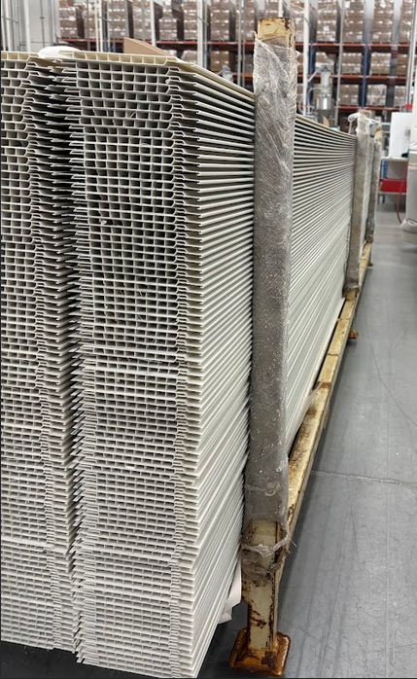

SEAWAY BUGGY

MATERIAL MUST BE FILLED UP NOT HIGHER THAN 6-8 INCHES (FROM THE TOP OF THE ARMS)

SECURE THE BUGGY WITH SHRINK WRAP AND ZIP TIGHT ACCORDING TO PACKAGING REQUIREMENT.

WHEN STACKING UP THE BUGGIES, MAKE SURE THAT WHEELS OF THE TOP BUGGIES WON’T TOUCH THE BOTTOM MATERIAL LIKE THE FOLLOWING PICTURES:
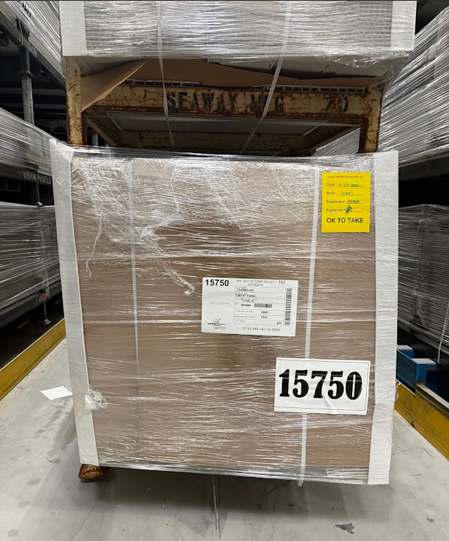
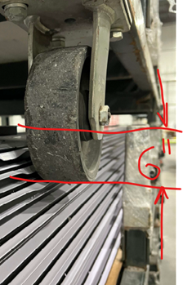
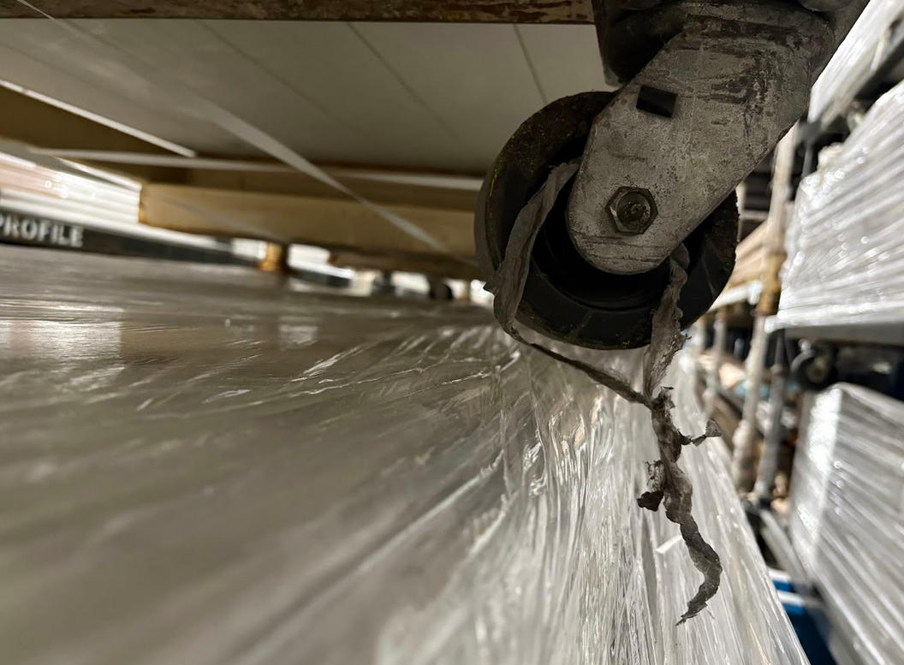

MUST LEAVE A GAP WHEN STACKING THE BUGGIES, MAKE SURE NO MATERIAL WILL BE DAMAGED AFTER STACKING

